

DEEQ 2139-16
16 December 2016

PRICON MICROELECTRONICS
LISP, Cabuyao
Laguna

ATTENTION : MR. ERIC GAMBOA

THRU : MS. REBECCA VALENZUELA

SUBJECT : MATERIAL RACK

Dear Sir:

We would like to thank you for giving us the privilege to quote your esteemed company for the above mentioned project and we trust you will find our offer reasonable according to your requirements.

I. PROJECT : ALUMINUM U-CHANNEL INSTALLATION

II. SCOPE OF WORK :

One(1) lot Supply of labor, materials, tools & equipment for the installation of aluminum U-channels on one (1) existing material
rack to wit :

- Supply only of cut to size SUS sheet, 1mm thk x 970mmD x 1230mmW
- Installation of aluminum u-channel, 4mm thk x 10mmH x 40mmW

III. PROJECT COST (VAT Excluded) :

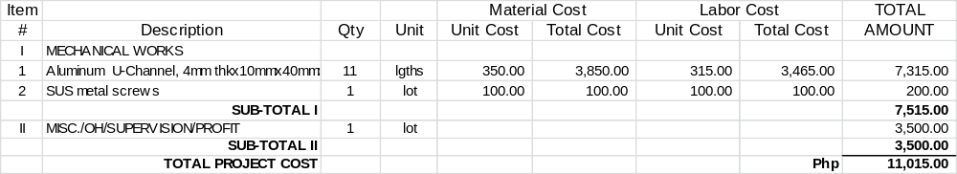

IV. OTHER DETAILS :

A. TERMS OF PAYMENT : Upon work completion

B. START OF WORK : 2 – 3 days upon receipt of P.O. & D.P.

C. DURATION OF WORK : 2– 4 working days

D. VALIDITY OF QUOTE : 7 days

GENERAL CONDITIONS:

- All works that will incur additional cost to labor and / or materials and equipment due to revision of plans, substitution of materials, relocation or transfer, deletion or addition not stated in this offer shall be paid by the client.

2.) Power and water supplies to be provided by the client.

Hope you find the above in order and we look forward to be of service to you. If you have further queries, please feel free to contact the undersigned.

Yours truly, Noted by :

_______________________ _____________________
EMMANUEL GARLAND ERNESTO L. LIJAUCO
Project Manager General Manager

